4/10/2025

Riphah International University

Lab: 07

COAL LAB

**Name:** Ayesha Tayyaba

**SAP ID:** 56546

**Department:** CS

**TASK: 01**

**Write an assembly language program that find the square of a number entered by user. Print the result on screen.**

**Source:**

.model small

.stack 100h

.data

msg db 13,10,'Square is: $'

.code

main proc

mov ax, @data

mov ds, ax

; Input a single-digit number

mov ah, 1

int 21h ; character input in AL

sub al, 48 ; convert from ASCII to number

mov bl, al ; save number in BL

; Square it

mul bl ; AL * BL = AX (result in AX)

; Show message

mov dx, offset msg

mov ah, 9

int 21h

; Separate tens and units

mov ah, 0

mov bl, 10

div bl

; Print tens digit

add al, 48 ; convert to ASCII

mov dl, al

mov ah, 2

int 21h

; Print units digit

mov al, ah

add al, 48

mov dl, al

mov ah, 2

int 21h

; Exit

mov ah, 4ch

int 21h

main endp

end main

**OUTPUT:**

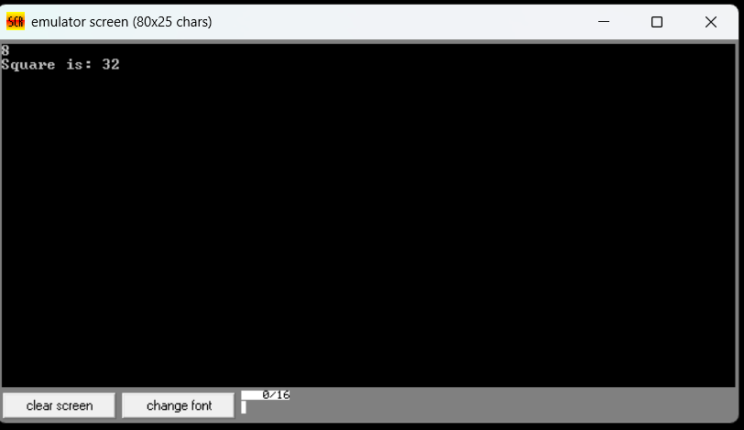

**Task: 02**

**Write an assembly language program that find the cube of a number entered by user. Print the result on screen.**

**Source:**

org 100h

.model small

.stack 100h

.data

msg db 'Enter a number: $'

resultMsg db 0Dh, 0Ah, 'The cube is: $'

number db ?

cubed db ?

.code

main proc

mov ax, @data

mov ds, ax

mov dx, offset msg

mov ah, 09h

int 21h

mov ah, 01h

int 21h

sub al, 48

mov number, al

mov al, number

mul al

mov bl, al

mov al, number

mul bl

mov cubed, al

mov dx, offset resultMsg

mov ah, 09h

int 21h

mov al, cubed

add al, 48

mov dl, al

mov ah, 02h

int 21h

mov ah, 4ch

int 21h

main endp

end main

**OUTPUT:**

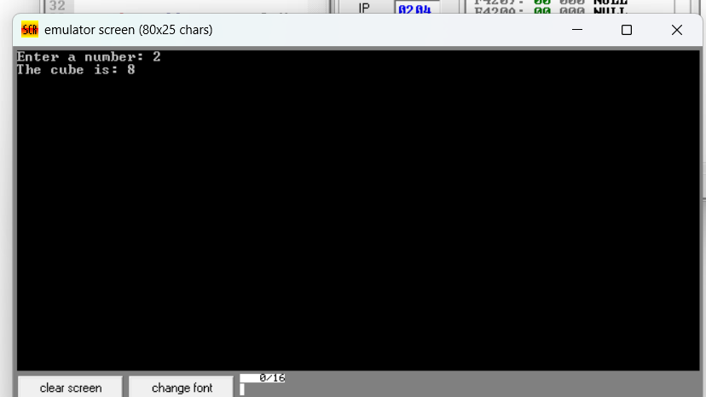

**Task: 04**

**Write an assembly language program that finds the area of a triangle. Hint: Area of triangle = ½ (Base ×Height)**

**Source:**

.model small

.stack 100h

.data

msg1 db 'Enter base: $'

msg2 db 13, 10, 'Enter height: $'

msg3 db 13, 10, 'Area of triangle is: $'

.code

main proc

mov ax, @data

mov ds, ax

; Prompt for base

mov dx, offset msg1

mov ah, 9

int 21h

; Read base

mov ah, 1

int 21h

sub al, 30h ; Convert ASCII to number

mov bl, al ; Store base in BL

; Prompt for height

mov dx, offset msg2

mov ah, 9

int 21h

; Read height

mov ah, 1

int 21h

sub al, 30h ; Convert ASCII to number

mov bh, al ; Store height in BH

; Calculate area = (base × height) / 2

mov al, bl

mul bh ; base × height ? AX

mov bl, 2

div bl ; AX / 2 ? result in AL

; Show result label

mov dx, offset msg3

mov ah, 9

int 21h

; Convert result (in AL) to ASCII and print

mov ah, 0

mov bl, 10

div bl ; AL / 10 ? AL = tens, AH = units

; Print tens digit (if not 0)

add al, 30h

cmp al, '0'

je skip_tens

mov dl, al

mov ah, 2

int 21h

skip_tens:

; Print units digit

mov al, ah

add al, 30h

mov dl, al

mov ah, 2

int 21h

; Exit

mov ah, 4ch

int 21h

main endp

end main

**OUTPUT:**

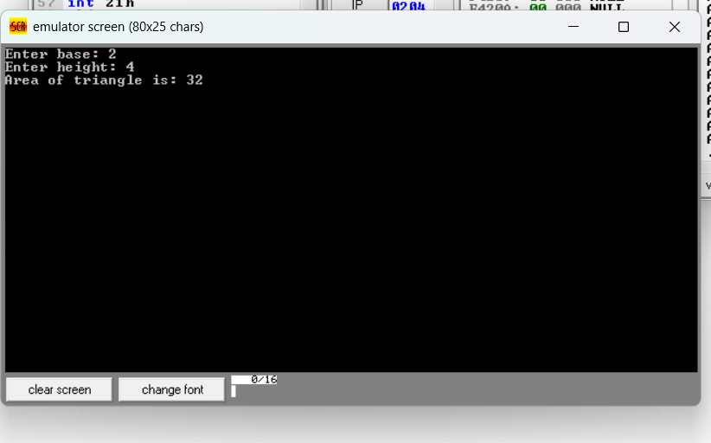

**Task: 03**

Perform multiplication of two numbers entered by user. Print the result on screen.

**Source code:**

.model small

.stack 100h

.data

prompt1 db "Enter first number: $"

prompt2 db "Enter second number: $"

newline db 0x0A, 0x0D, '$'

.code

main proc

; Initialize Data Segment

mov ax, @data

mov ds, ax

; Print prompt for first number

mov ah, 09h

lea dx, prompt1

int 21h

; Input first number (character input)

mov ah, 01h

int 21h

sub al, '0'

mov bl, al

; Print prompt for second number

mov ah, 09h

lea dx, prompt2

int 21h

; Input second number (character input)

mov ah, 01h

int 21h

sub al, '0'

mov cl, al

; Multiply the numbers (first * second)

mov al, bl

mov ah, 00h

mul cl

; Move result to DX for output

mov dx, ax

; Convert result (AX) to ASCII and print it

add dl, 48

; Print result

mov ah, 02h

int 21h

; Print newline (move to next line)

mov ah, 09h

lea dx, newline

int 21h

; Exit program

mov ah, 4Ch

int 21h

main endp

end main

**OUTPUT:**

